**Project Design Phase-II Customer journey map**

|  |  |
| --- | --- |
| Date | 08 October2022 |
| Team ID | PNT2022TMID34648 |
| Project Name | Personal expense tracker |

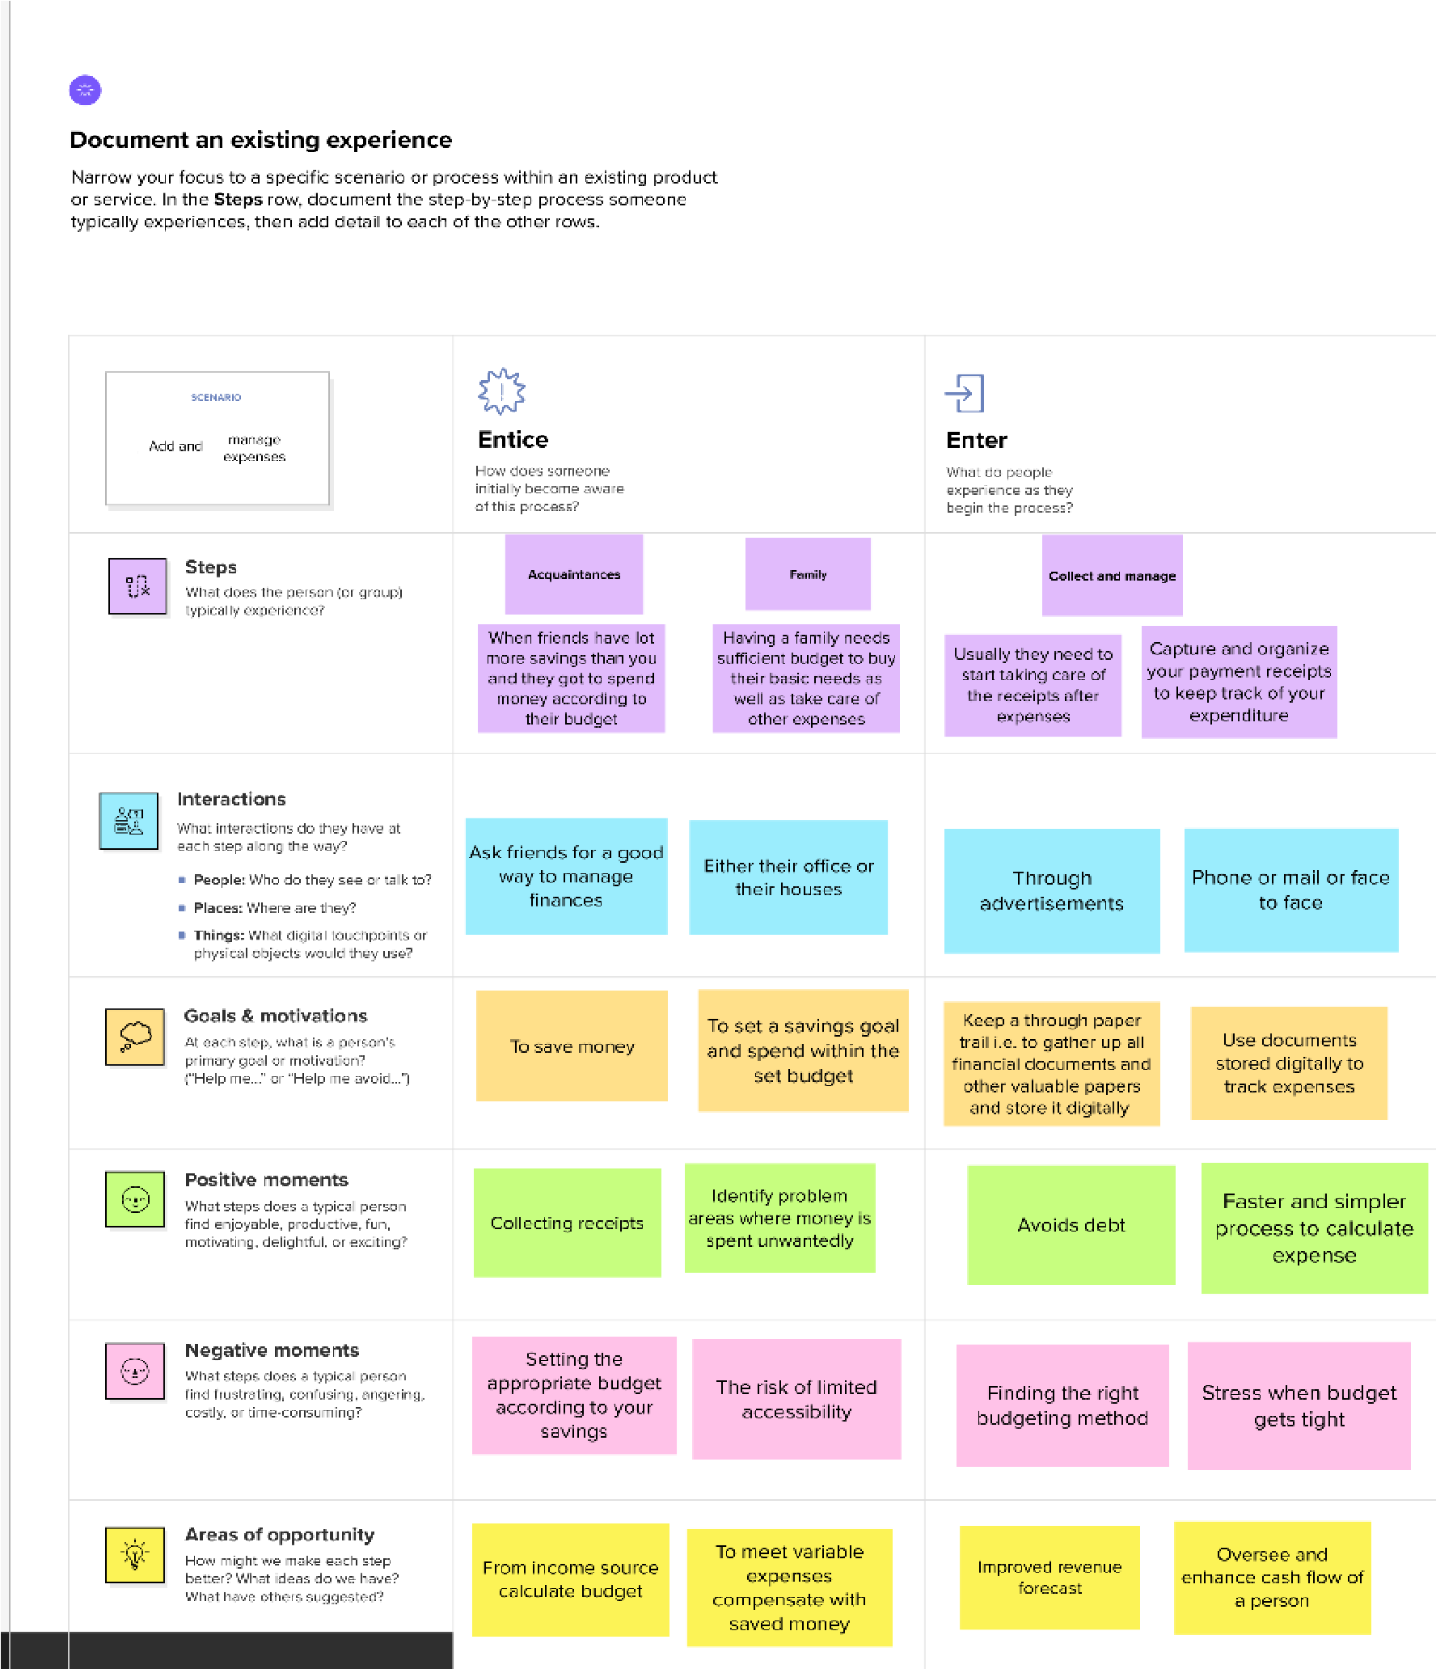

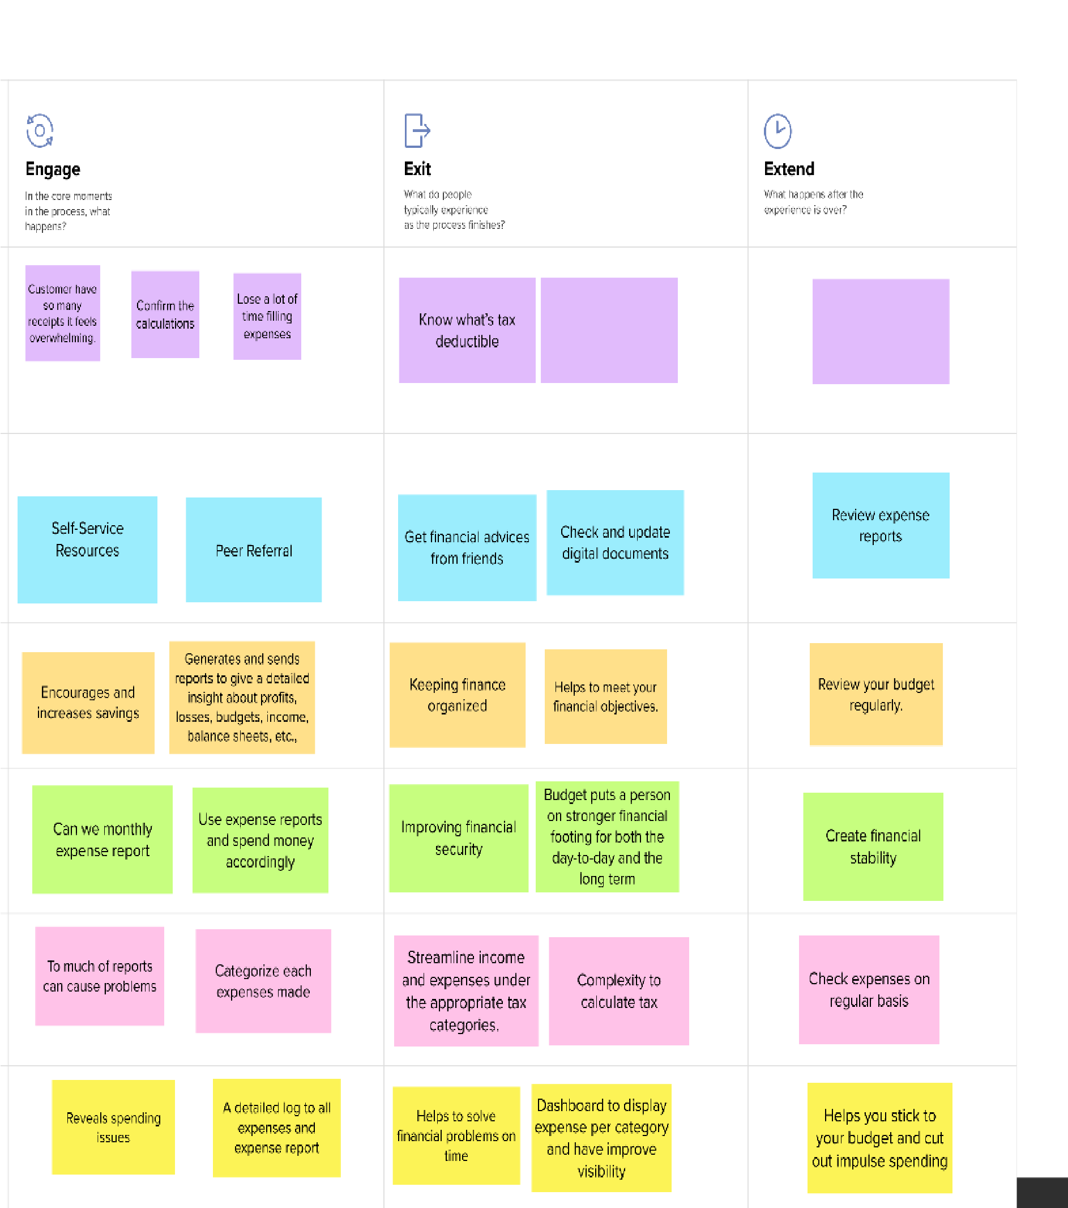

References:

https://app.mural.co/t/ibmproject9647/m/ibmproject9647/1665222938278/6c5f19baf6cb673f71a

4418892c6863acb7a0ec0?sender=ue9426ac28ac7be9365f28602